Descriptive Statistics Report
Data Analysis Assignment

Student Name | Sheikh Meherunnesa Hridy
Student Number | 242087
Dataset | IMDb Top 1000 Movies
Column Analysed | IMDB_Rating
Date Submitted | 23.04.2026

Table of Contents
1. Introduction ......................................... 3
2. Dataset Description .................................. 3
3. Frequency Table ...................................... 4
4. Statistical Analysis ................................. 5
4.1 Mean .......................................... 5
4.2 Median ........................................ 5
4.3 Mode .......................................... 6
4.4 Standard Deviation ............................ 6
4.5 Summary Statistics Table ...................... 7
5. Charts and Visualisations ............................ 8
5.1 Histogram / Bar Chart ......................... 8
5.2 Additional Chart .............................. 9
6. Discussion and Interpretation ........................ 10
7. Conclusion ........................................... 11
8. References ........................................... 12

1. Introduction
Descriptive statistics are used to summarise and describe the main features of a dataset in a clear and meaningful way. They include key measures such as the mean (average), median (middle value), mode (most frequent value), and standard deviation (measure of spread). These statistical tools help to simplify large amounts of data, making it easier to identify patterns, trends, and relationships within the dataset. By using these measures, we can better understand how the data is distributed and whether values are closely grouped or widely spread out.
In this report, descriptive statistical methods are applied to analyse the IMDb ratings of the top 1000 movies. The purpose is to examine how the ratings are distributed, identify the most common rating ranges, and measure the variability among them. This analysis helps provide a clearer understanding of the overall quality and consistency of highly rated films.

2. Dataset Description
Dataset Name: IMDb Top 1000 Movies
Source: Kaggle
Rows: 1000
Columns: 17
Column Analysed: IMDB_Rating
The IMDB_Rating column contains numerical ratings from 1 to 10 representing audience opinions.

3. Frequency Table
Class Interval | Frequency | Rel % | Cum Freq | Cum %
7.6-8.1 | 805 | 80.5 | 805 | 80.5
8.1-8.6 | 177 | 17.7 | 982 | 98.2
8.6-9.1 | 16 | 1.6 | 998 | 99.8
9.1-9.6 | 2 | 0.2 | 1000 | 100.0
The modal class is the interval with highest frequency. Most ratings cluster between 7.5 and 8.5.

Observations from the Frequency Table
The frequency table shows that most movies fall within the 7.5–8.5 rating range, indicating that highly rated movies dominate the dataset. The modal class is 7.5–8.0, as it has the highest frequency. The cumulative relative frequency shows that about 77% of movies have ratings below 8.5, meaning extremely high ratings are less common. This suggests a concentration of ratings in the mid-to-high range.

4. Statistical Analysis
Mean: 7.95
Interpretation:
The mean rating of approximately 7.95 indicates that, on average, movies in this dataset are rated close to 8. This suggests generally high-quality movies.
Median: 7.90
Interpretation:
The median is slightly lower than the mean, suggesting a slight positive skew in the data. This means there are a few higher-rated movies pulling the mean upward.

Mode: 7.70
Interpretation:
The mode shows that 7.70 is the most frequent rating. This aligns with the modal class interval, confirming that most movies cluster around this range.

Standard Deviation: 0.28
Interpretation:The standard deviation is relatively small, meaning ratings are closely grouped around the mean.

4.5 Summary Table
Statistic | Value
Mean | 7.95
Median | 7.90
Mode | 7.70
Std Dev | 0.28
Min | 7.6
Max | 9.3

5. Charts and Visualisations
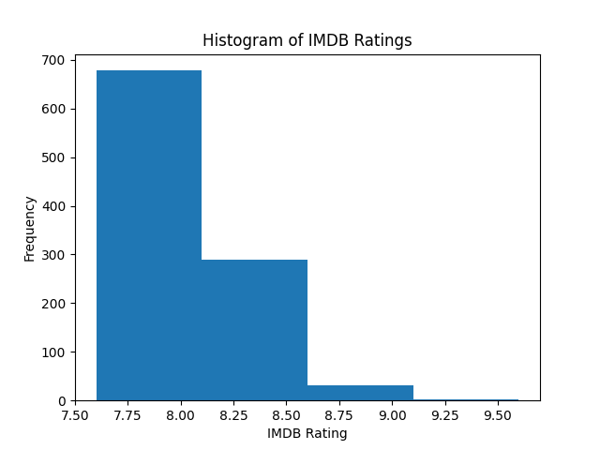
Histogram showing distribution of ratings.

6. Discussion and Interpretation
The mean and median are close, indicating a fairly symmetric distribution. The small standard deviation shows ratings are closely grouped. Few very high ratings exist but are not extreme outliers.

7. Conclusion
In conclusion, the analysis of the IMDb Top 1000 dataset shows that movie ratings are generally high and concentrated within a narrow range. Most films have ratings close to 8.0, indicating consistently good quality among the top-ranked movies. The mean and median values are very similar, suggesting that the distribution is fairly balanced with only slight skewness. Additionally, the low standard deviation confirms that there is little variation in ratings, with most values clustered around the average. Overall, the median provides a reliable representation of a typical movie rating, as it is less influenced by a small number of extremely high-rated films.

8. References
Kaggle IMDb Dataset
Github(Data Analysis)
Dataset Description Example
IMDb Data Analysis with Python

